GitHub Version Control Guidelines
To ensure a streamlined and efficient version control process, the following rules must be adhered to when working on the project:
1. Branching Strategy
- Always create a feature branch from the master branch.
  - Naming Convention: feature/branch-name (e.g., feature/add-user-login).
- Never directly commit changes to the master branch.
- Use the following primary branches:
  - Master: Contains the stable and production-ready code.
  - Develop: Used for testing and integration of feature branches before merging to master.
2. Workflow for Feature Branches
- Create a new feature branch from the master branch:
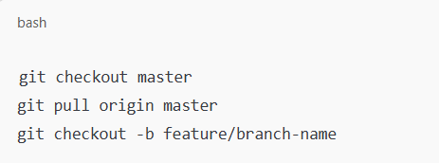
- Make changes and commit them locally to your feature branch.
- Push the feature branch to GitHub:
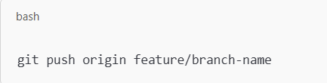
3. Testing on develop Branch
- Once your feature branch changes are ready, merge them into the develop branch for testing:
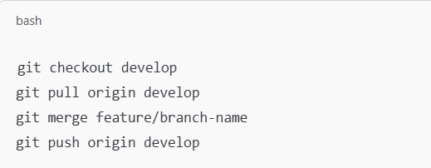
- Test thoroughly on the develop branch to ensure no issues arise.

4. Merging to master
- After successful testing, merge your feature branch into the master branch:
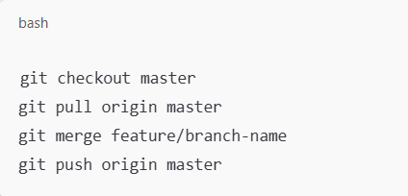
5. Handling Conflicts
- In case of conflicts during the merge, create a conflict branch from your feature branch:
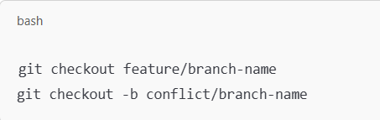
- Resolve the conflicts and commit the changes to the conflict branch:
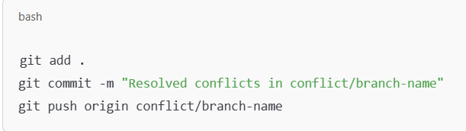
- After resolving, make minor changes in your feature branch and attempt the merge again.
- Once resolved and merged, delete the conflict branch:
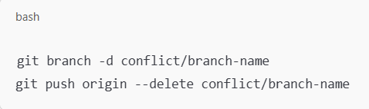

6. Additional Best Practices
- Always sync with master before creating a feature branch:
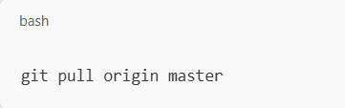
- Write clear and concise commit messages describing the changes made.
- Regularly pull updates from the master and develop branches to avoid large conflicts:
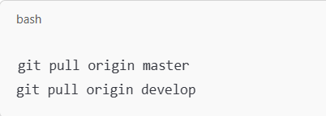
- Delete feature branches from GitHub after they are merged into master:
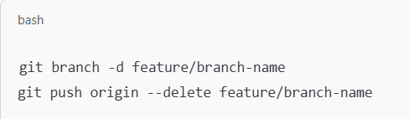
- Never force push to master or develop.

By following these rules, we ensure a clean, collaborative, and efficient version control workflow that minimizes conflicts and enhances project productivity.

